FILE TRANSFER PLATFORM
@CREATIVITY THINK (9483175986/7019689991)

ABSTRACT:
The File Transfer Platform is a secure, web-based system designed to manage uploading, receiving, and sharing of files across users within an organization. The platform ensures safe transmission, permission-based access control, and comprehensive transfer logs, providing users with an organized history of activities. Administrators gain visibility into all file operations, including uploads, downloads, permissions, and analytics. Built with Django and Django Rest Framework on the backend and React for the frontend, the system delivers efficient file handling, dashboard analytics, and a seamless user experience. It serves as a scalable, high-performance file management solution for both small and large institutions..

INTRODUCTION OF THE PROJECT:
In most organizations, file transfer activities take place through email, chat applications, or unmanaged storage platforms, causing difficulties related to size limitations, data security, and traceability. These methods lack proper permission settings, centralized logs, and administrative controls. The File Transfer Platform addresses these gaps by providing a unified interface for secure file transfers, permission management, and activity monitoring. Users can share files effortlessly, while administrators can regulate access, analyze usage data, and maintain complete system governance. This project enhances collaboration and ensures a reliable, structured approach to document exchange..

PROJECT OBJECTIVES:

• Provide a secure platform for file upload and transfer
• Allow users to set and manage file permissions
• Maintain accurate logs of uploads, downloads, and updates
• Offer dashboards and visualization tools for file statistics
• Enable administrators to manage permissions and monitor system activity
• Deliver scalable APIs for handling large files efficiently
• Ensure privacy, integrity, and safe access to all shared content
• Support exporting analytical reports for decision-making

PROBLEM OF THE STATEMENT:
Organizations often rely on email-based file sharing, which introduces issues such as file size limits, security vulnerabilities, and lack of structured history logs. Users find it difficult to track previously shared files or manage access control. Administrators lack the ability to supervise activity across the system. The File Transfer Platform provides a centralized and secure solution to these problems with permission-controlled file sharing, automatic logging, analytics, and complete administrative oversight..

MOTIVATION OF THE PROJECT:
• To replace unstructured methods of file sharing
• To provide reliable, secure, and permission-based file access
• To support accountability through detailed activity logs
• To streamline internal communication and file tracking
• To empower administrators with full system visibility
• To make file management fast, organized, and user-friendly
• To enhance productivity across departments using digital workflows

BLOCK DAIGRAM OF PROJECT:

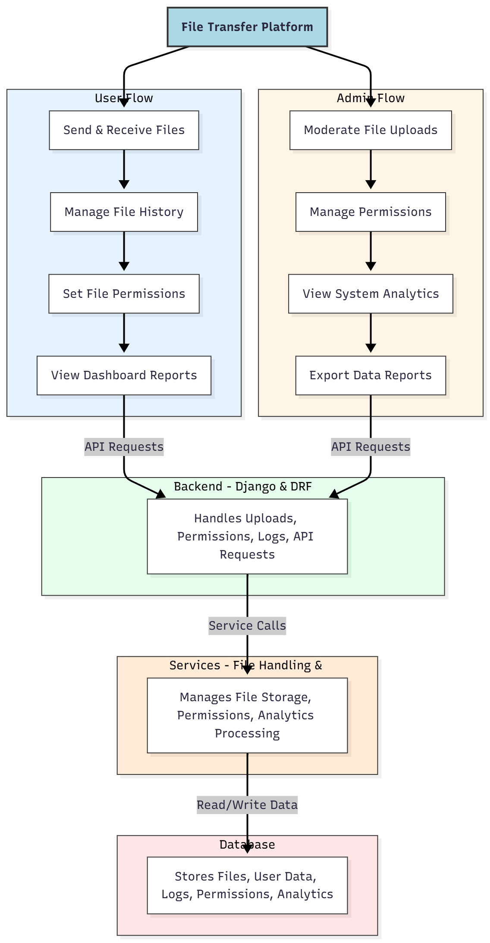

WORKING OF THE PROJECT:
The workflow begins when a user uploads a file. The system validates file type, size, and access rights before storing it securely in the backend. The upload event is logged automatically. Users may share files, apply permissions, or track activities using their dashboard. When a user downloads or updates a file, the system records the action for transparency. Administrators monitor all activities, manage user permissions, and analyze insights through graphical dashboards. The services module processes analytics and validates permissions, while the database stores all file metadata, user details, and logs, ensuring a smooth and secure transfer mechanism..

SOFTWARE REQUIREMENT:
- Backend:
  - Python 3.x
  - Django
  - Django REST Framework
  - SQLite/PostgreSQL
- Frontend:
  - Node.js and npm
  - React.js
  - Axios
- Development Tools:
  - Visual Studio Code
  - Postman (for testing APIs)
  - Git/GitHub (for version control)
- Server/Deployment (Optional):
  - Gunicorn, Nginx, or Heroku/AWS for hosting

ADVANTAGES OF THE PROJECT:

• Secure and reliable file transfer system
• Permission-based sharing for controlled access
• Complete history logs for every file activity
• Dashboard analytics for user and admin insights
• Efficient handling of large files
• Reduces dependency on email and chat apps
• Enhances collaboration within organizations
• Centralized storage and faster accessibility

APPLICATIONS OF THE PROJECT:
• Businesses and corporate offices
• Educational institutions
• IT support and service teams
• HR and training documentation systems
• Inter-team collaboration workflows
• Secure internal file sharing

REFERENCES:

- Django REST Framework Documentation — Django Software Foundation. Django Documentation. Available: https://docs.djangoproject.com/
- Django REST Framework. DRF Documentation. Available: https://www.django-rest-framework.org/
- React. React Official Documentation. Available: https://reactjs.org/docs/getting-started.html
- Redux. Redux Documentation. Available: https://redux.js.org/introduction/getting-started
- PostgreSQL Global Development Group. PostgreSQL Documentation. Available: https://www.postgresql.org/docs/
- MySQL. MySQL Reference Manual. Available: https://dev.mysql.com/doc/
- Git. Git Documentation. Available: https://git-scm.com/doc
- Node.js. Node.js Documentation. Available: https://nodejs.org/en/docs/
- Axios. Axios Documentation. Available: https://axios-http.com/docs/intro
- Socket.io Documentation – https://socket.io/docs/

